**Who Deals with Contracts?**

Before we dive into Contract Lifecycle Management (CLM) functionality, we'll spend some time answering some key questions such as: Who deals with contracts? What can CLM do? What is its business value?

**Contract Stakeholders**

Salesforce Industries provide a collaborative platform to efficiently manage contracts. As the foundation of most business transactions, contracts touch many departments and many stakeholders across an enterprise. Stakeholders have their own objectives and challenges when it comes to drafting, negotiating, and registering contracts.

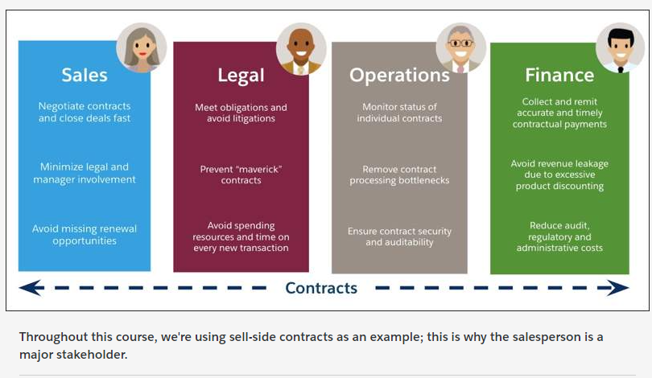

Contract Lifecycle Management (CLM) Functional Capabilities

* Operations Role (System Admin)
  + **Contract Types:** Allows you to manage different types of contracts within one org. You can configure each contract type to provide access to the users, define contract stages and approval processes, define specific clauses and templates and specify parameters such as DocuSign reminders.
  + **Lifecycle Configuration:** Each contract has a "lifecycle" that it progresses through, based on your compliance requirements. Each implementation of Salesforce Industries CLM may have a different requirement for what the lifecycle needs to be. A Contract State Model determines the lifecycle for a specific contract type, controlling which actions and operations are available for certain users at each stage in the lifecycle.
* Functional/Business Analysts
  + **Clause Library:** The Clause Library (Vlocity Document Clauses) is where you store and manage pre-approved legal language and terms, or any language that a document needs to include; for example, payment and warranty clauses. Thinks of clauses as the smallest building block in the construction of a contract document. You can reuse them across multiple document templates. This helps to make the contract creation process more standardized and repeatable.
  + **Online Template Designer:** Use the Document Template Designer (Vlocity Document Templates) to build document templates, so that your generated contract documents automatically conform to corporate legal standards. Document Templates define the structure, content, and formatting of a contract or any type of document. Templates can be created and maintained with minimal or no IT support. You can create three types of templates (Web HTML, Microsoft Word .DOCX, and Microsoft PowerPoint .PPTX). JSON-based data mapping is available for all types, and object-based mapping is also available for web templates.
* Contract Manager
  + **Dynamic Document Generation:** Documents are generated dynamically from document templates. You can use document authoring capabilities to generate dynamic documents for use cases outside of CLM, such as Quote documents, Order forms, and so on.
  + **CLM CPQ Integration:** Contracts are integrated within the sales process. You can create a contract from an opportunity, quote or order, and it flows to the next stage of the sales process.
  + **Document Management:** The document generation process involves merging contract data with its template definition and replacing all tokens in the template. When generated, documents are stored and versioned. You can perform various contract document operations on each contract document version. These operations are Vlocity Actions. The Contract State Model controls the available operations for each version, who can perform them, and when.
  + **Document Redlining:**During contract customization and negotiation, you can redline specific changes in the online contract document, which then go through an internal approval process. Use redlining for tracking changes in the different versions of the document during the authoring process.
  + **Word Doc Reconciliation:**You can import and reconcile documents negotiated offline with Microsoft Word. You can sync the customer's updates with your latest online version. You can also attach the returned document to the contract record.
  + **Document Comparison:**When a contract document has more than one version, you can perform a side-by-side comparison of any two versions online. Redlines how the difference between them.
  + **Renewal Opportunities:** You can generate renewal notifications for expiring contracts to ensure revenue opportunities are not missed.
  + **Renew, Amend, or Terminate:**You can manually renew or extend, amend and terminate contracts (or terminate contract lines).
  + **Frame Agreement-based Pricing:** It is a pricing-based agreement that you negotiate with your customer for a list of products and services over a given period of time. This type of agreement drives the pricing of related quotes/orders based on the contract line item prices.
* Managers, Legal/Finance Depts
  + **Approval Workflows:**Using standard Salesforce approval workflows, you can send the contract for internal approval before sending it to customer during the negotiation stage. Managers or other departments can approve or reject redlined contract documents.
* Customers
  + **eSignature with DocuSign:**Salesforce Industries CLM integrates with DocuSign to enable eSignatures.  When the contract document is finalized and approved, email it to the appropriate recipients for their signature. After all signatures are done, DocuSign returns the signed document, which can be automatically attached back to the latest version of the contract. After all parties have signed, the contract is Approved and goes into effect.

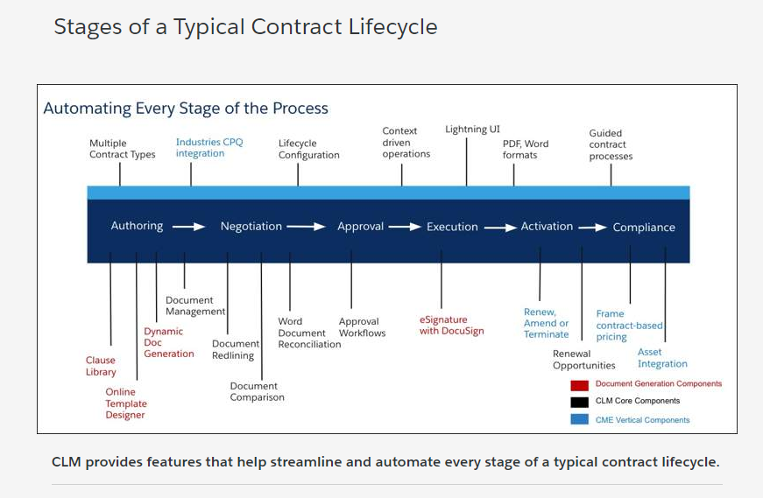

These are the business benefits our customers see when they adopt CLM:

* Reduced Contract Cycle Times
  + The complete automation and streamlining of the contract lifecycle means you can close deals much faster resulting in acceleration of cash flows.
* Increased Contract Renewal Rates
  + Renewal opportunities are automatically created for salespeople well in advance for them to work on soon expiring contracts. Renewals are not delayed or missed, which helps you increase revenue.
* Reduced Administrative Overheads
  + Contract process standardization and digitization reduces administrative and material costs (elimination of paper), and other overheads such as courier costs.  This helps you reduce operational expenses.
* Enhanced Compliance Management
  + Contracts Management ensures that contract obligations are met, contracts confirm to internal company policies, and have full auditing capabilities for compliance reviews.  This helps reduce your financial and legal risk.
* Process Digitization = Enhanced Experience and Customer Satisfaction
  + The end-to-end digitization of the process such as the ability to review and sign documents electronically enhances the customer experience.
  + This helps you increase your customer satisfaction.

# How Do Customers Adopt CLM?

Salesforce Industries find that customers who are looking to adopt CLM are at one of five levels of maturity in terms of managing their contracts and their contracting processes. Either they don't use a CLM application to manage their contracts, use a homegrown CLM application, or sometimes use a CLM application from another vendor that they want to replace.

**CLM Adoption Maturity Levels**

After adopting CLM, your organization can quickly move up the maturity curve

